VR University

Final Deliverable

TecX

Design & Developed by:
Evense Zetrenne
Stephen Robinson
Brandon Papadakis

V 1.0
1. Overall Description

1.1 Product Perspective

VR University will be the first of its kind. We are designing an app that not only allows its users to tour college campuses of their choice, they can do so by fully immersing themselves in the content they are consuming. This is possible with the technology of virtual reality. This app is designed for potential students who are physically unable to travel to their school of interest. These individuals will include but are not limited to students with disabilities and international students looking to attend school in the United States. This software is meant to be a standalone product as it is not a part of any other family of software.

1.2 User Classes and Characteristics
- prospective students who are financially incapable of traveling to different cities/states/countries
- prospective students who are physically unable to tour their campus of choice. This includes those with disabilities
- international prospective students whom traveling to locations such as Tampa, FL would be a hassle.
- No high-level knowledge on virtual reality or software development will be required for any user to use this application

1.3 Operating Environment

The operating environment needed to allow this software to operate will be:

- iOS 8
- iOS 9
- iOS 10
- Android 5.0 (Lollipop)
- Android 6.0 (Marshmallow)

1.4 User Documentation
There is no user manual or documents provided. All instructions on how to use software will be through user's previous VR experience and experience gained from use. Users can use youtube.com for video tutorial on how to use personal VR device.

1.5 Assumptions and Dependencies
- A vital assumption is that the user’s smartphone will be physically compatible with Google Cardboard or other 3rd party “low-tech” VR headsets. The phone must be able to fit securely into the headset of choice.

- Another vital assumption is that the app developed by TecX, VR University, will be accepted onto the Apple App Store and the Google Play Store. The app must pass all necessary requirements set forth by Apple Inc. and Google Inc. for the App Store and Play Store respectively.

- One assumption about the product is that it will always be used on mobile phones that have enough performance. If the phone does not have enough hardware resources available for the application, for example the users might have allocated them with other applications, there may be scenarios where the application does not work as intended or even at all.

1.6 Changes in design over time
Initially, we had planned to develop the virtual environment and UI separately, and then attach the UI to the virtual environment when both were in a stable, working state, using Unity and Android Studio. However, we later learned that it is not possible to proceed this way, and that we had to make the UI on top of the virtual environment. This removed the need for Android Studio and led to the project be made entirely in Unity.

Additionally, we had intended to make even more virtual environment files, having multiple for each building as we did with the MSC. Unfortunately, we were not away ahead of time that you cannot take pictures at USF without prior permission. This led us through a time consuming process of completing paperwork and getting them to the right people and then waiting for approval before we could proceed with our work. We also had to scrap any material we had made prior to getting permission. Due to this constraint, we unfortunately ran out of time and could not reach our anticipated amount of images

Furthermore, another intent we had at the beginning was to implement geo location tracking services. The purpose was to allow the user to see recommended tours if they were in the same geo-location. We decided to remove this feature because we deemed it unnecessary and counterproductive to the direction we were going with the app.
2. Project Screenshots
2.1 Non-VR Menus

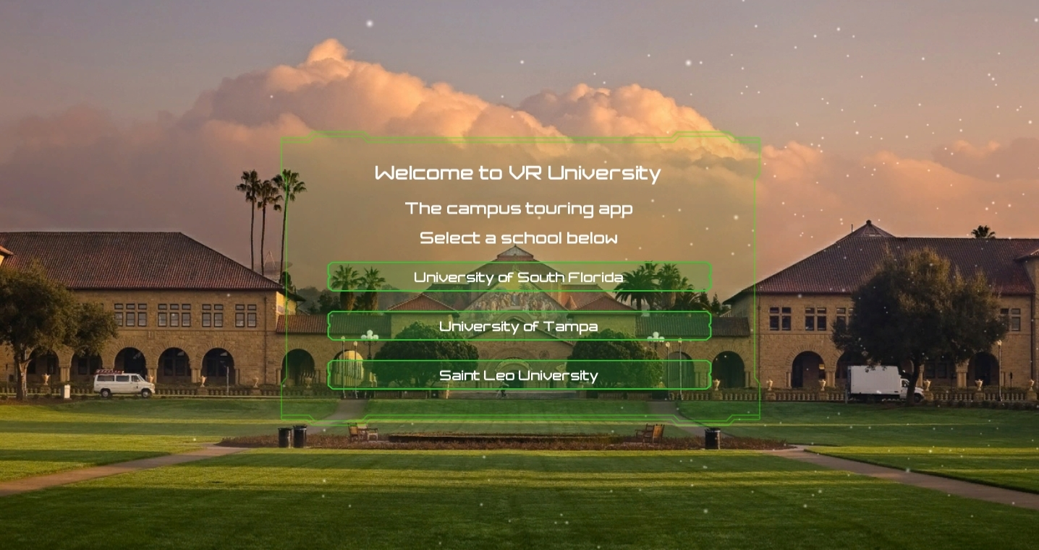
Main menu page, leads to university pages

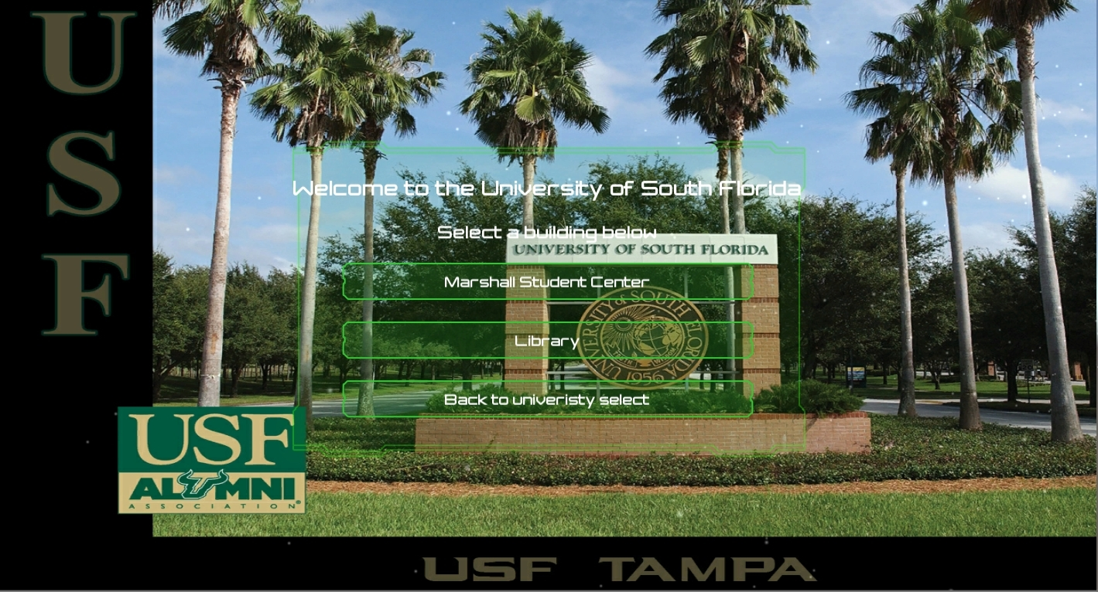

USF menu page, leads into USF building pages

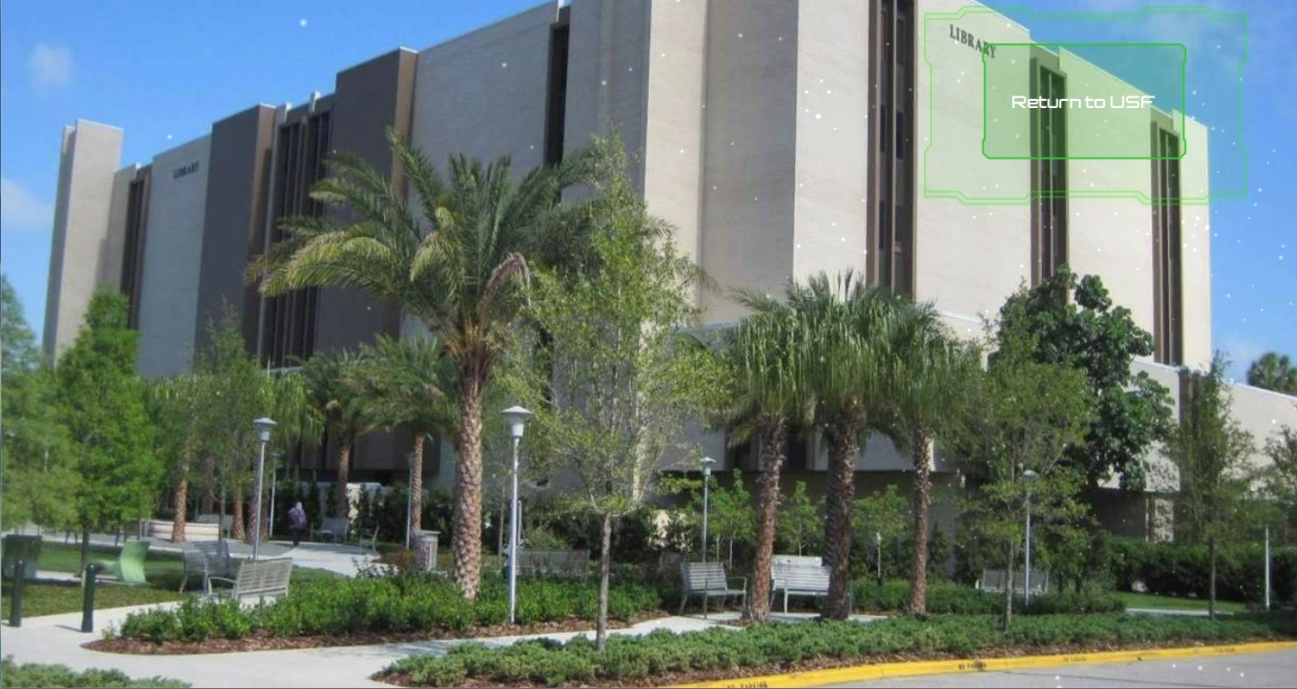

USF library page, contains information about USF’s library

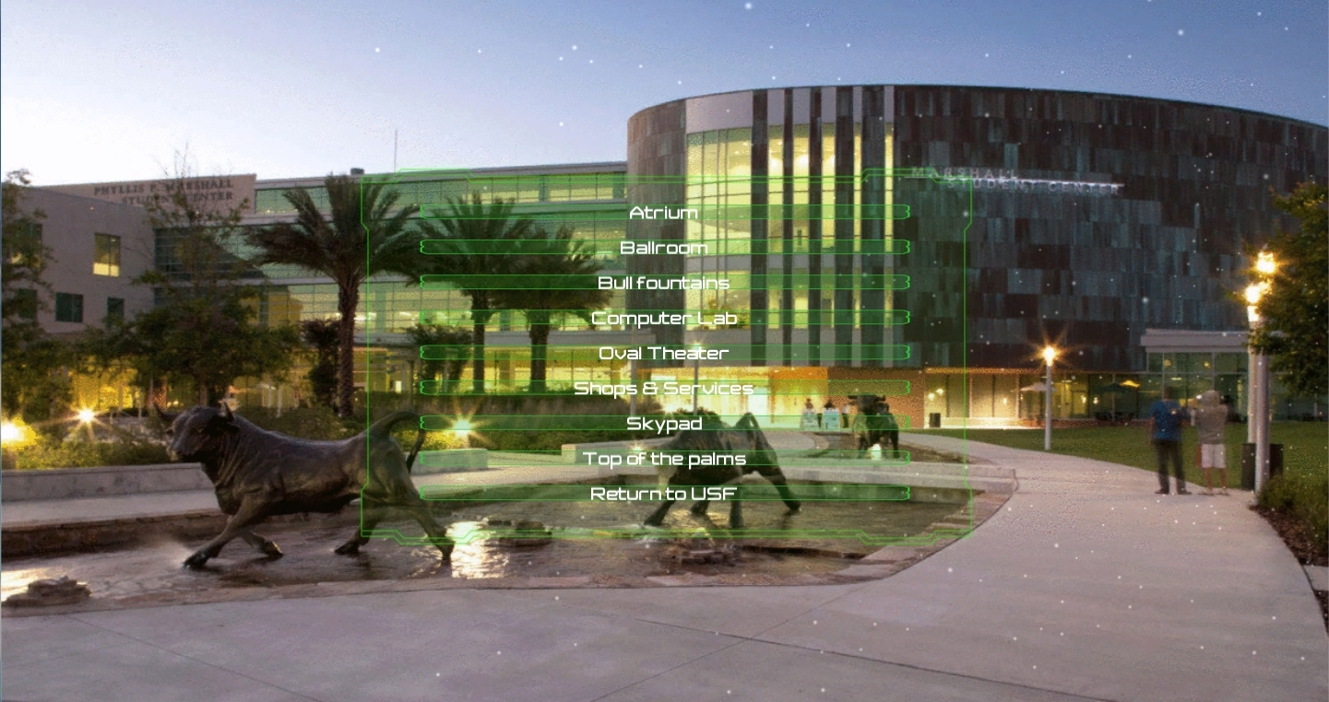

USF Marshall Student Center page, contains links to virtual environments of MSC rooms

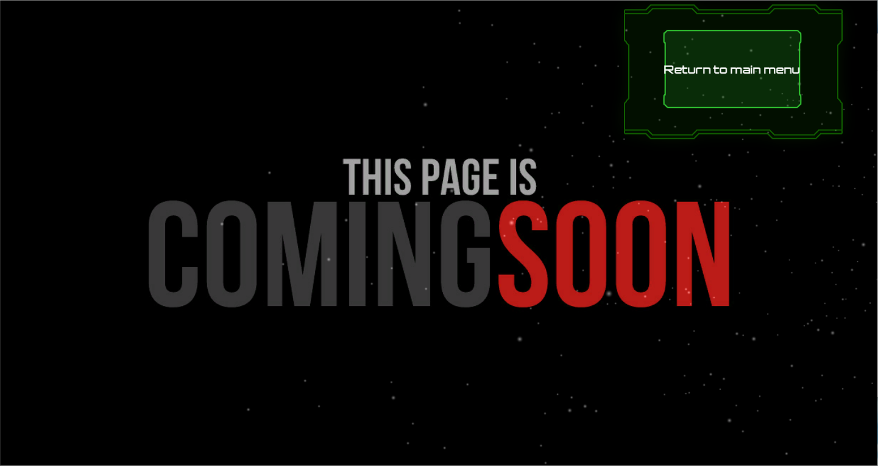
Pages to expand app in future releases

2.2 VR View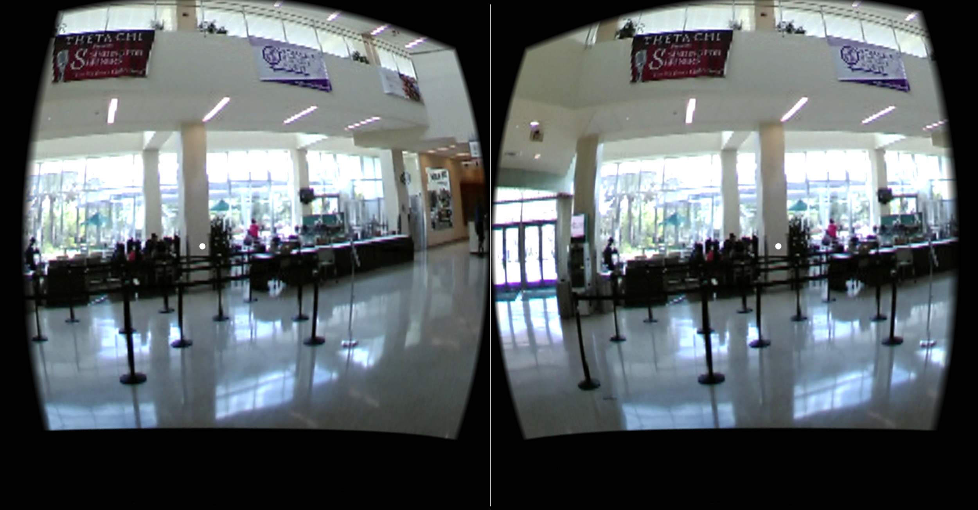
This image above is a screenshot taken of the virtual tour of USF’s Marshall Student Center. The scene currently being viewed is the Student Center’s atrium.

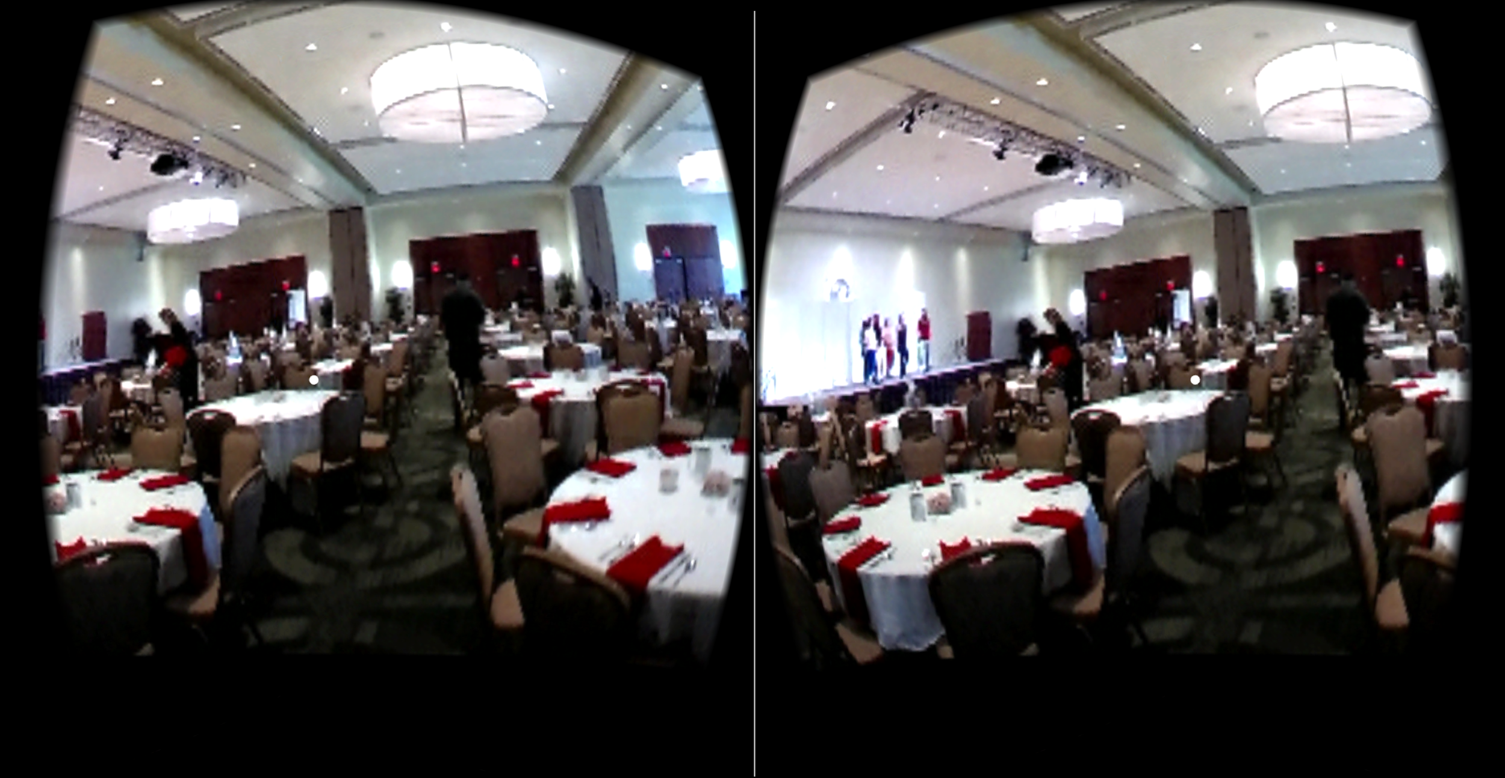
This image above is a screenshot taken of the virtual tour of USF’s Ballroom. Located on the second floor of the USF Marshall Student Center.

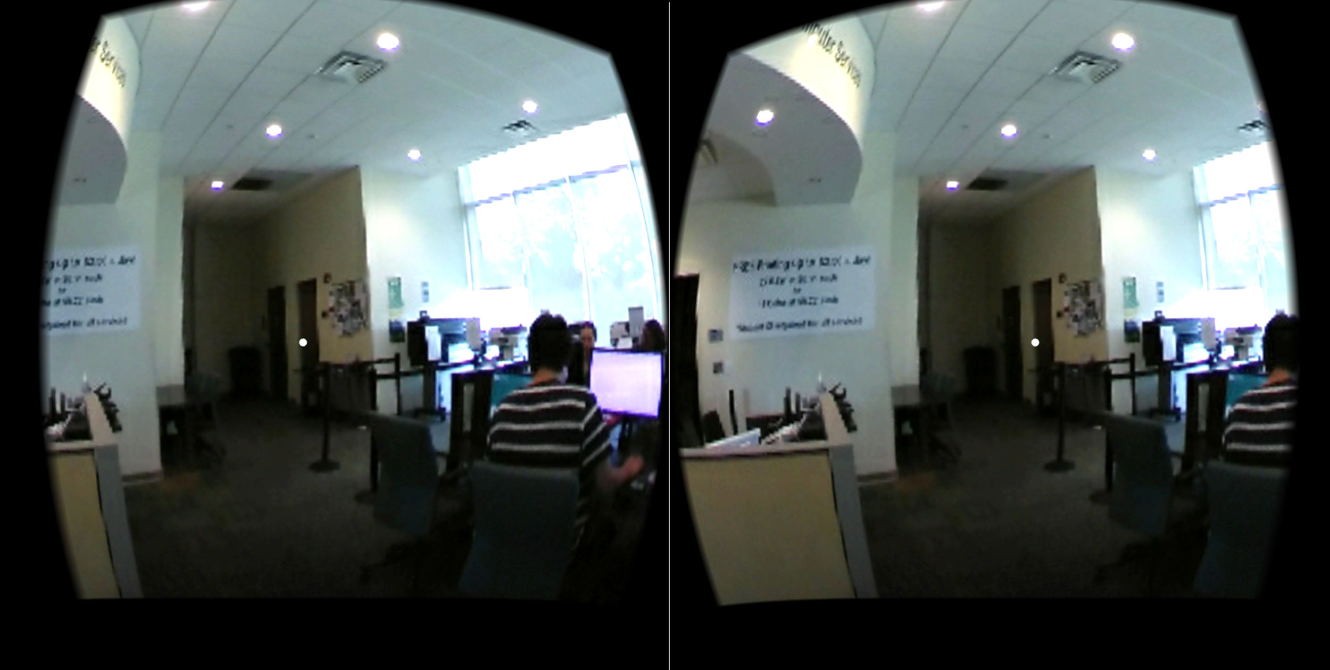
This image above is a screenshot taken of the virtual tour of USF’s computer lab. Located on the outside of the USF Marshall Student Center.

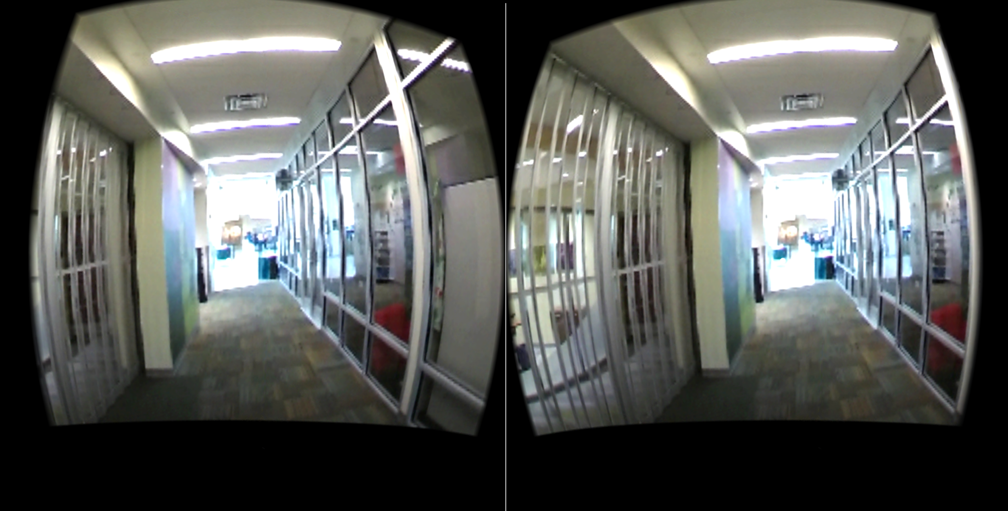
This image above is a screenshot taken of the virtual tour of USF’s Shops and Services hallway. Located on the first floor of the USF Marshall Student Center.

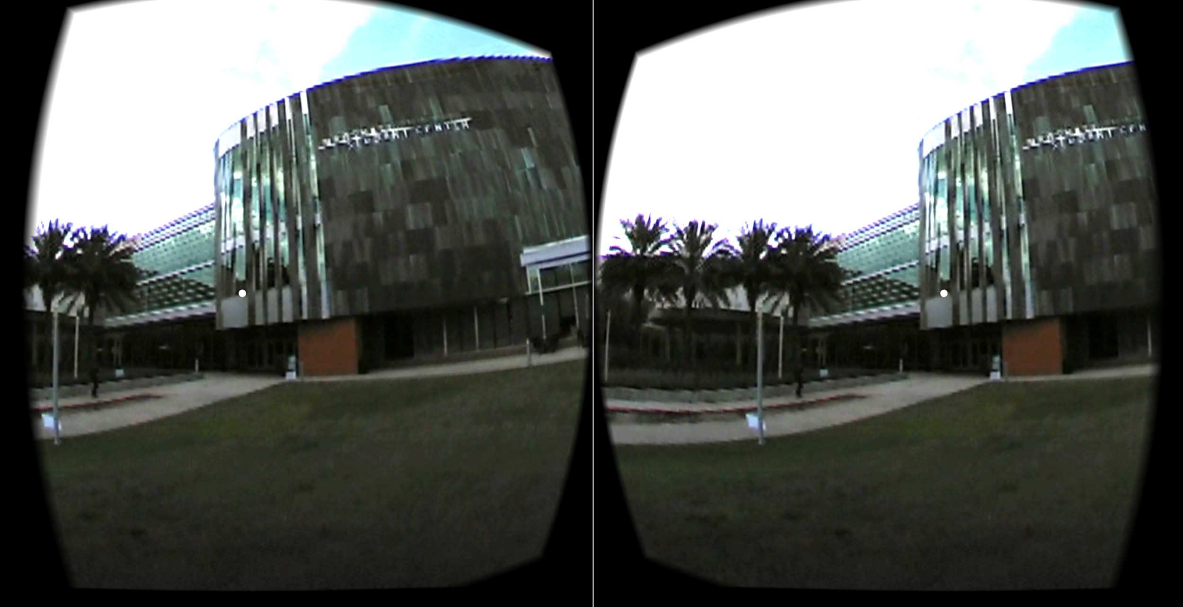
This image above is a screenshot taken of the virtual tour of outside USF’s Marshall Student Center.

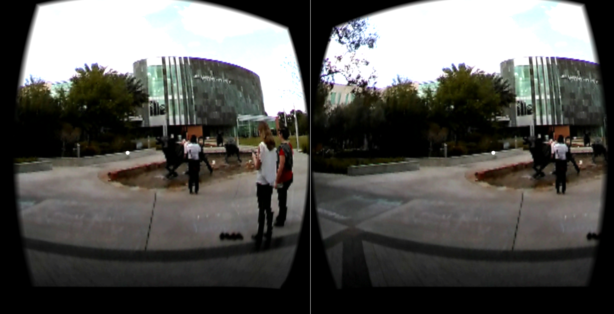
This image above is a screenshot taken of the virtual tour of outside USF’s Marshall Student Center.

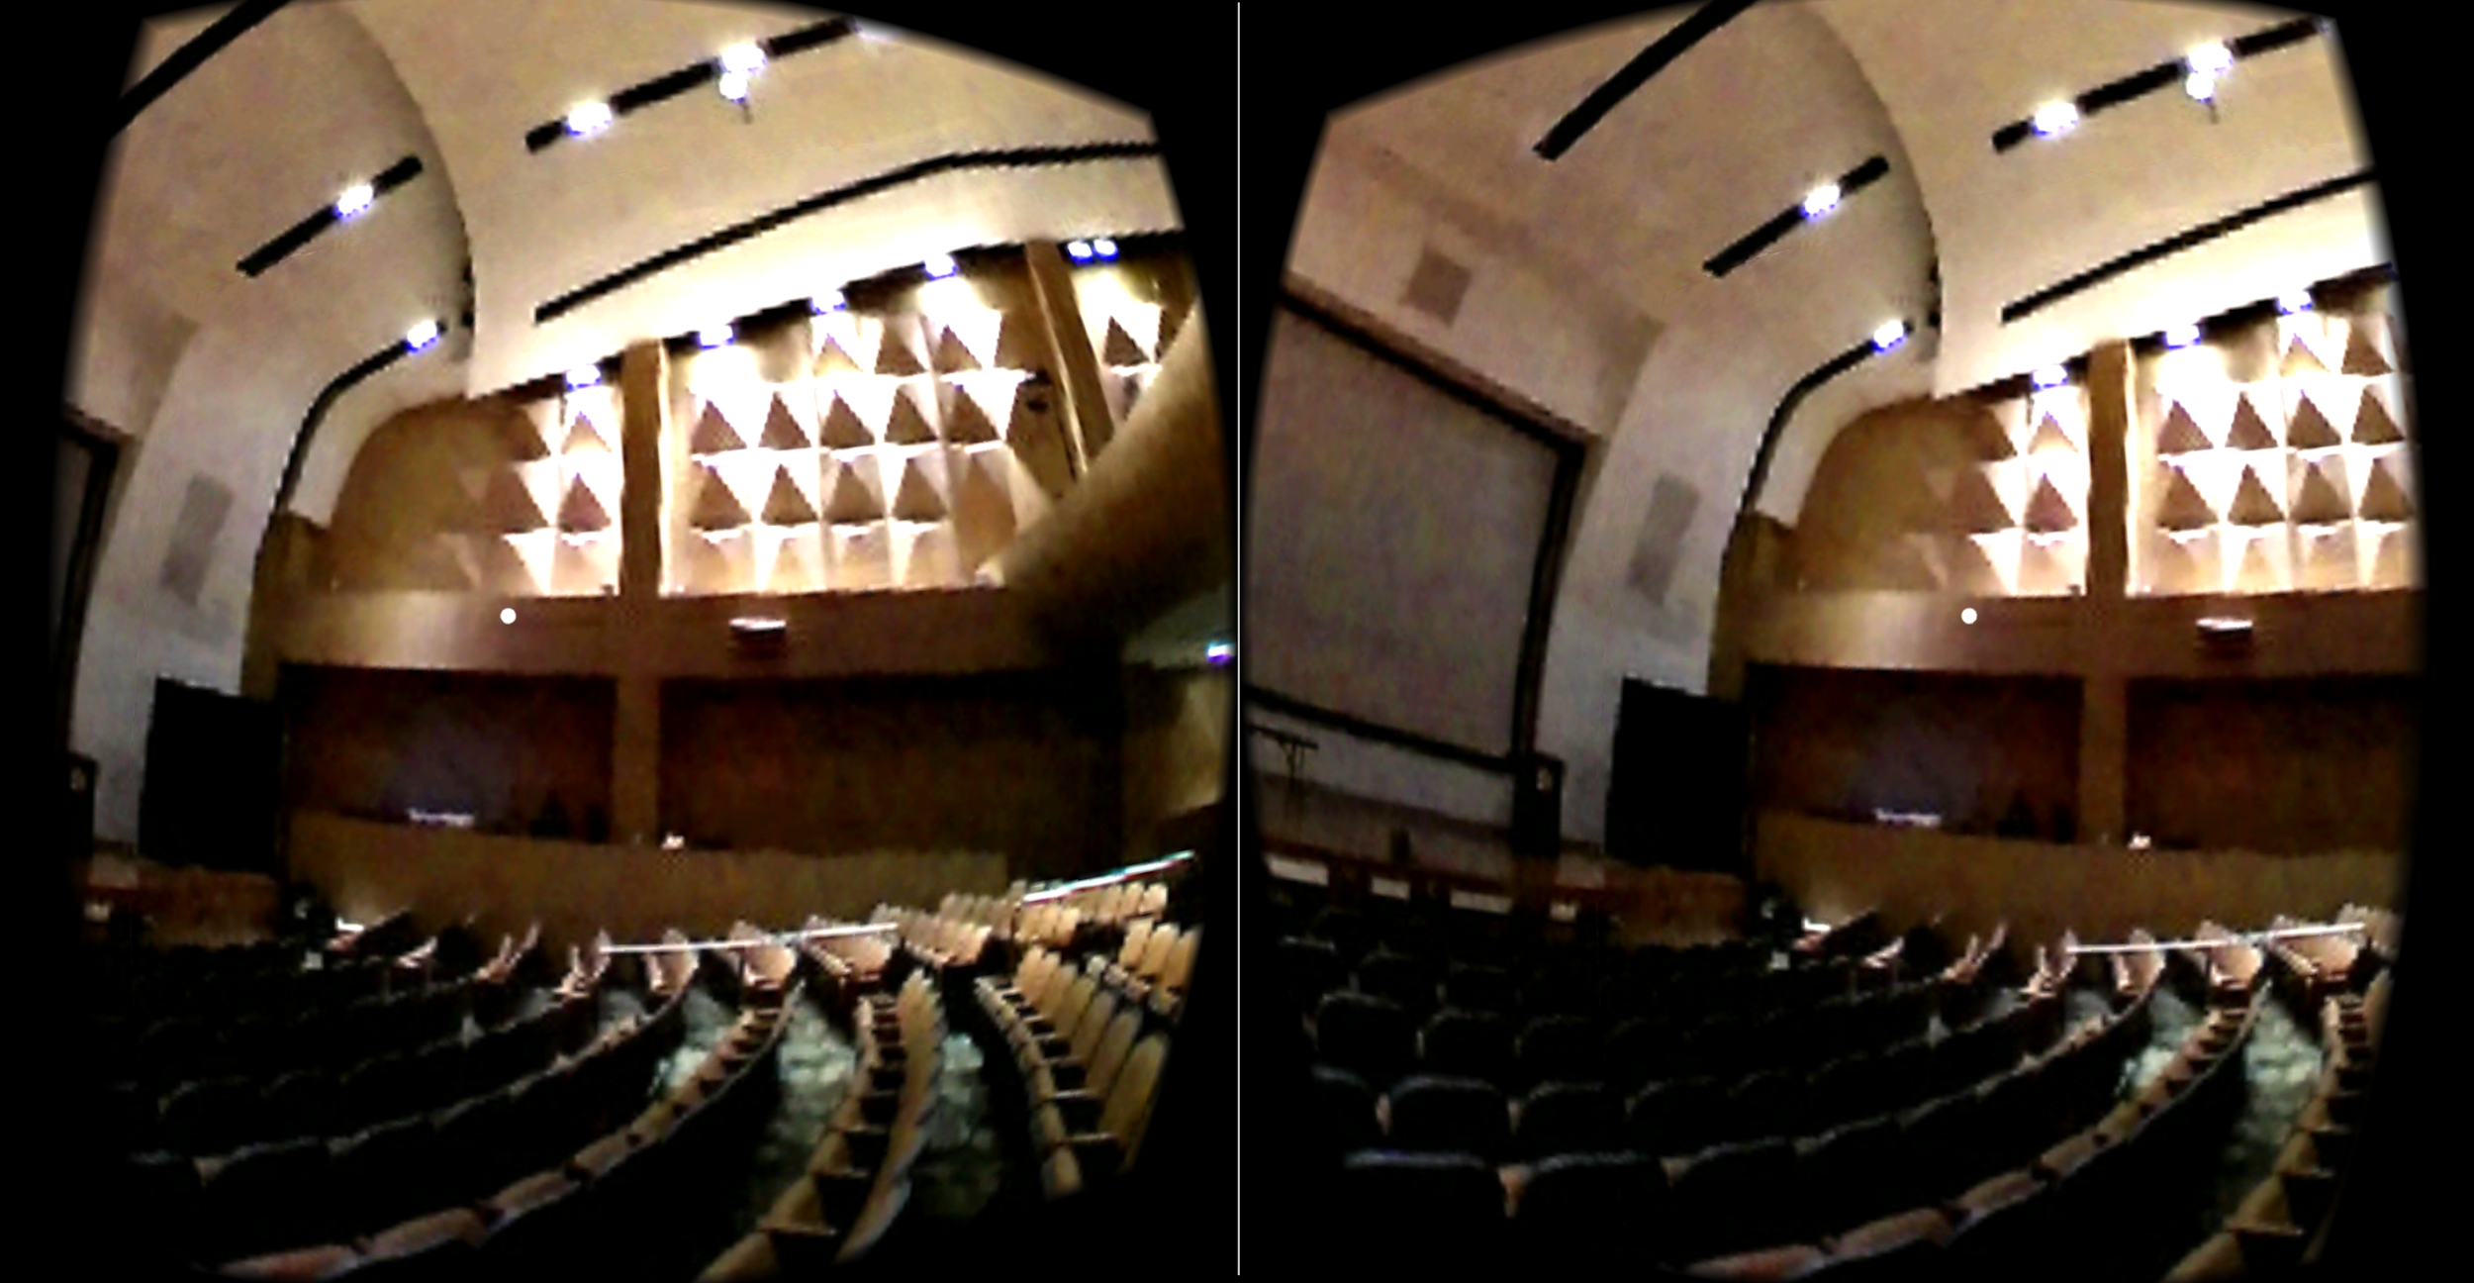
This image above is a screenshot taken of the virtual tour of USF’s Oval Theater. It is located at the second floor of the USF Marshall Student Center.

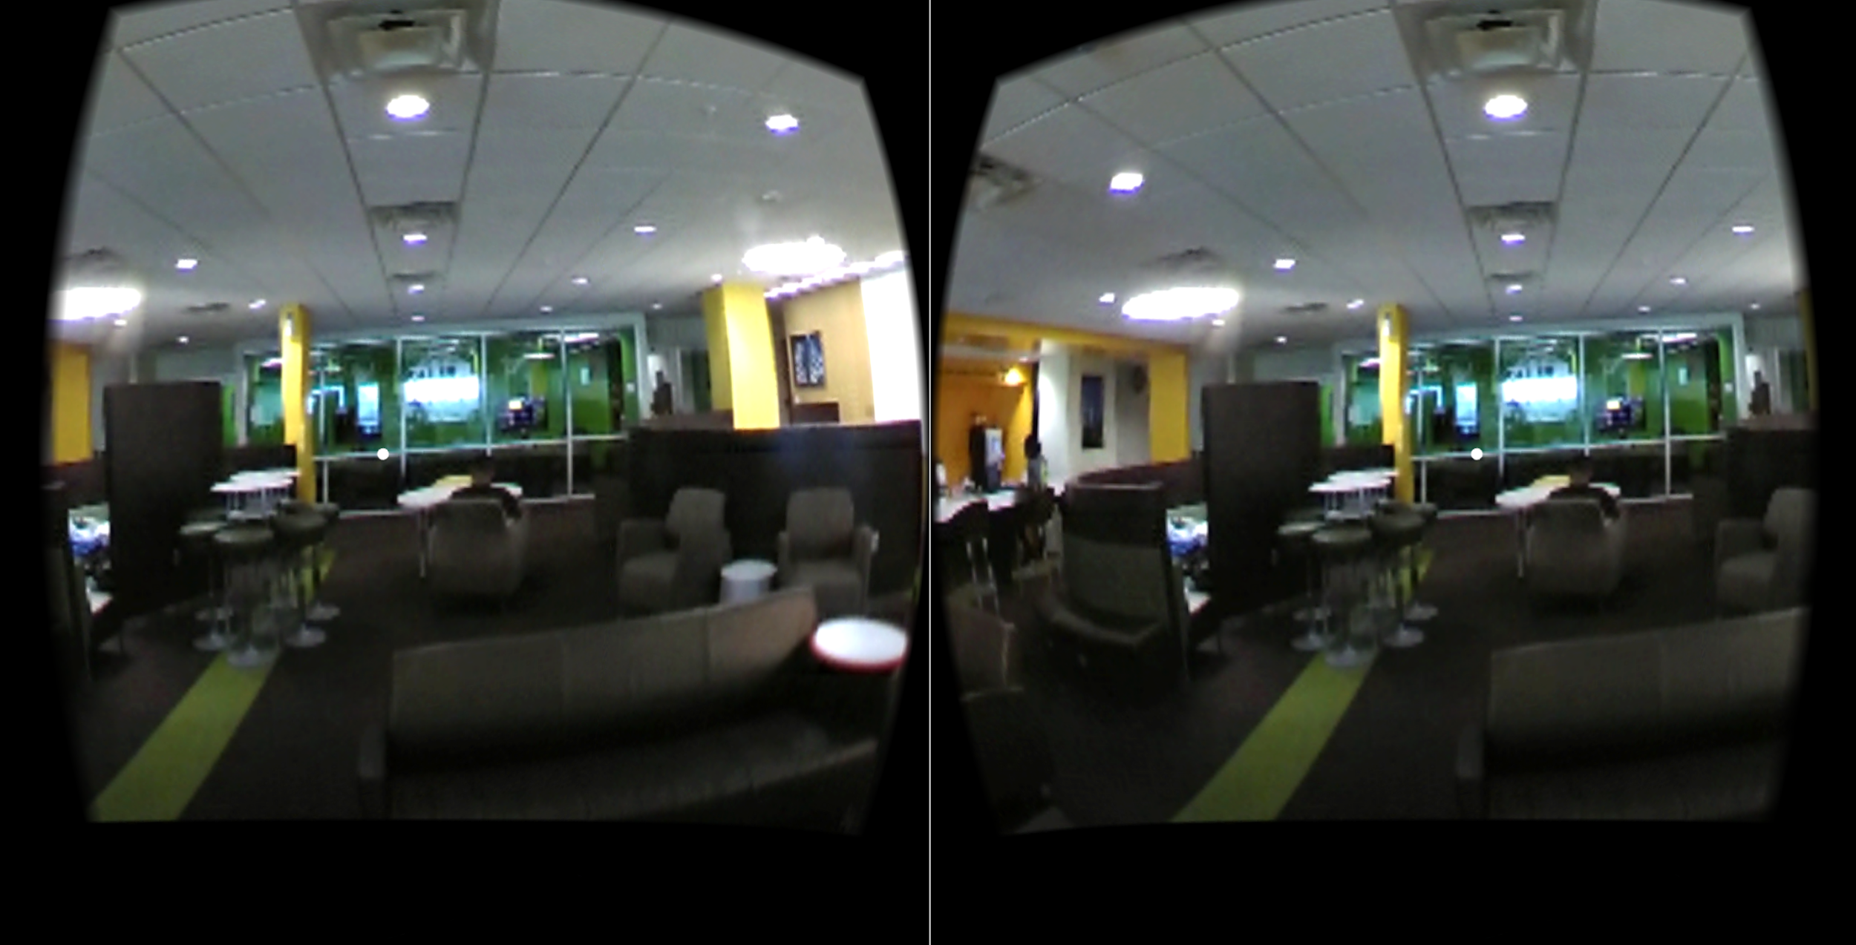
The image above shows a screenshot of the virtual tour of USF’s Skypad. Located on the fourth floor of the USF Marshall Student Center

2.3 Diagram of VR scenes
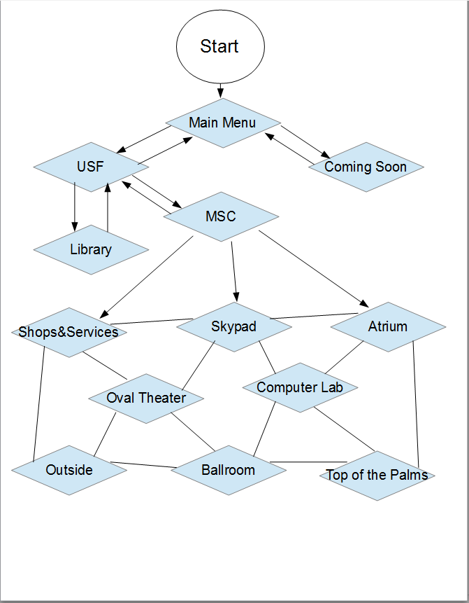Diagram depicting the structure of the app
3. References

3.1 Information

The references below were used to provide user interface guiding, hardware interface, and different type of headsets that is required for use of the application:

https://support.google.com/cardboard/manufacturers/answer/6323398?hl=en
https://unity3d.com/learn/tutorials/topics/virtual-reality/user-interfaces-vr
https://www.kohls.com/product/prd-2732106/venetian-worldwide-master-view-rk5-vr-headset.jsp
https://www.youtube.com/watch?v=OWtQnZsSdEU&t=1874s

The references below were used to provide imagery for the app:

http://www.nghltd.com/index.php
http://dconnerassociates.com/project/phyllis-p-marshall-student-center-university-of-south-florida/
https://wallpaperstock.net/stanford-university_wallpapers_44937_1280x1024_1.html
http://www.tbo.com/northeast-tampa/then--now-usf-library--and--b82497091z1
http://www.usfalumni.org/s/861/02-alumni/index.aspx?pgid=298

